WMD Industrial Technology (Xiamen) Co.,Ltd

WMD FORM MACHINE
MANUAL

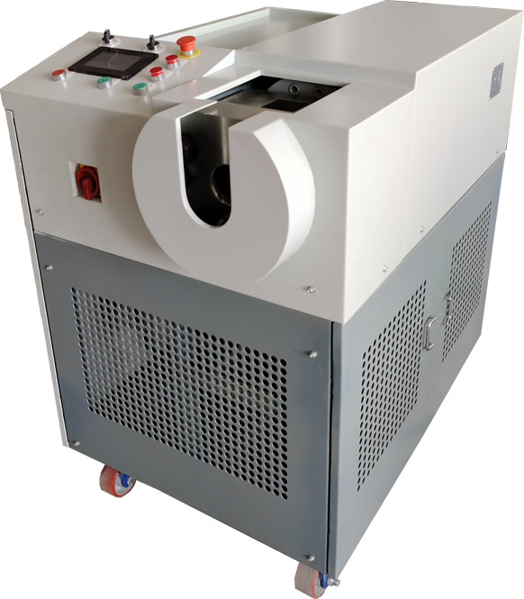

reliable, cost-effective, and leak-free connection solutions

●Overwiew：
- Machine
- Die
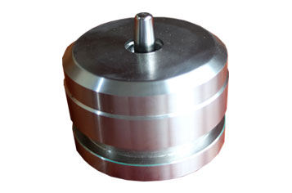
- Jig
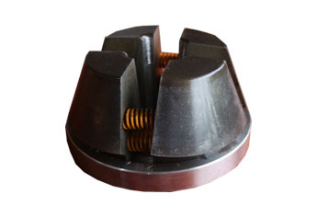
- SQR Nut & o-ring…
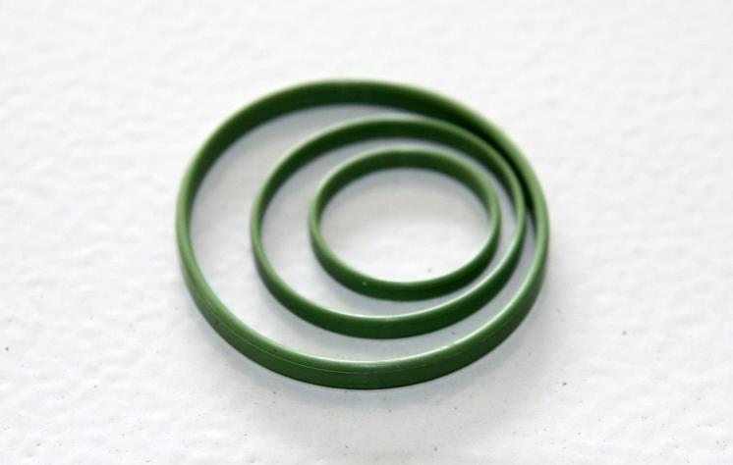

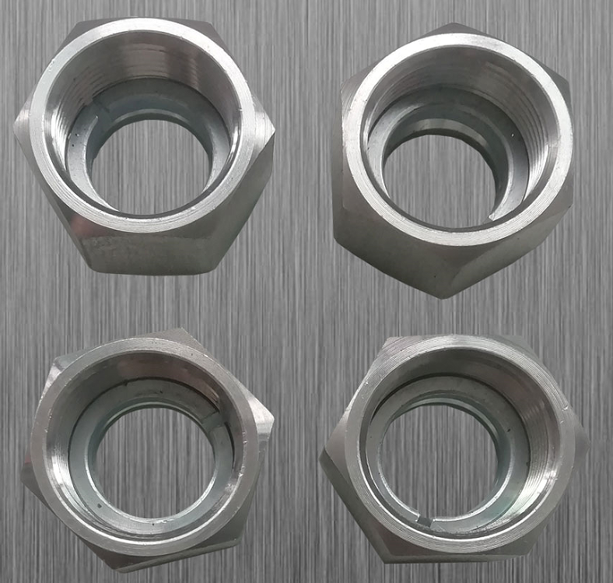

WMD Form Machine training video
link：https://pan.baidu.com/s/1F5ratnmSi6PQlUU8ZOPqqQ
Pin code：1234
●Key Parlance
Stop Block L1.5

Die Slot
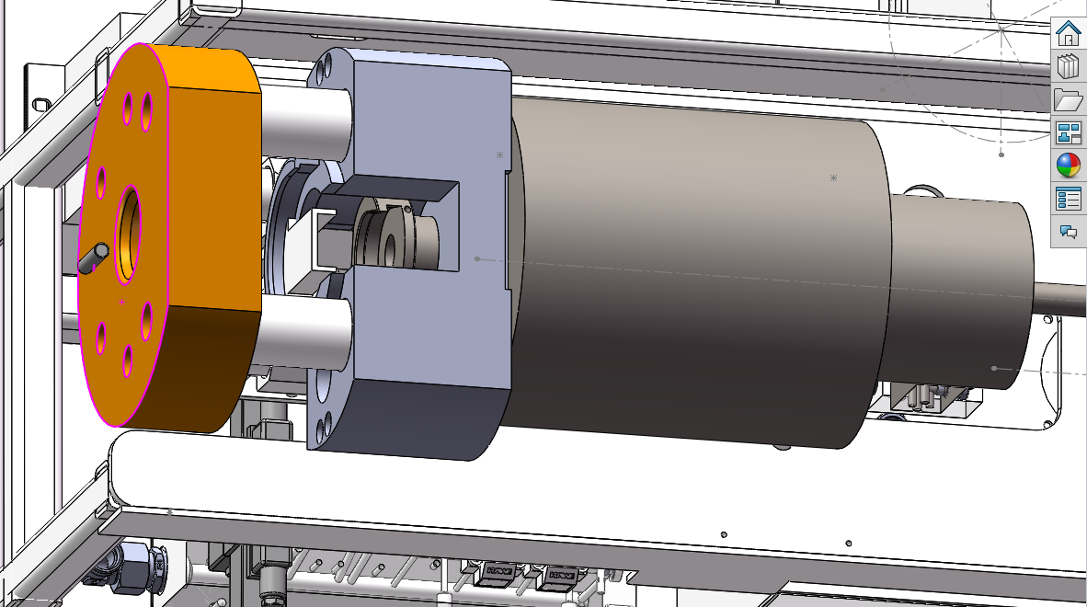
L1.4

Clamp Cylinder
Stop Plate
Block1
Main Cylinder
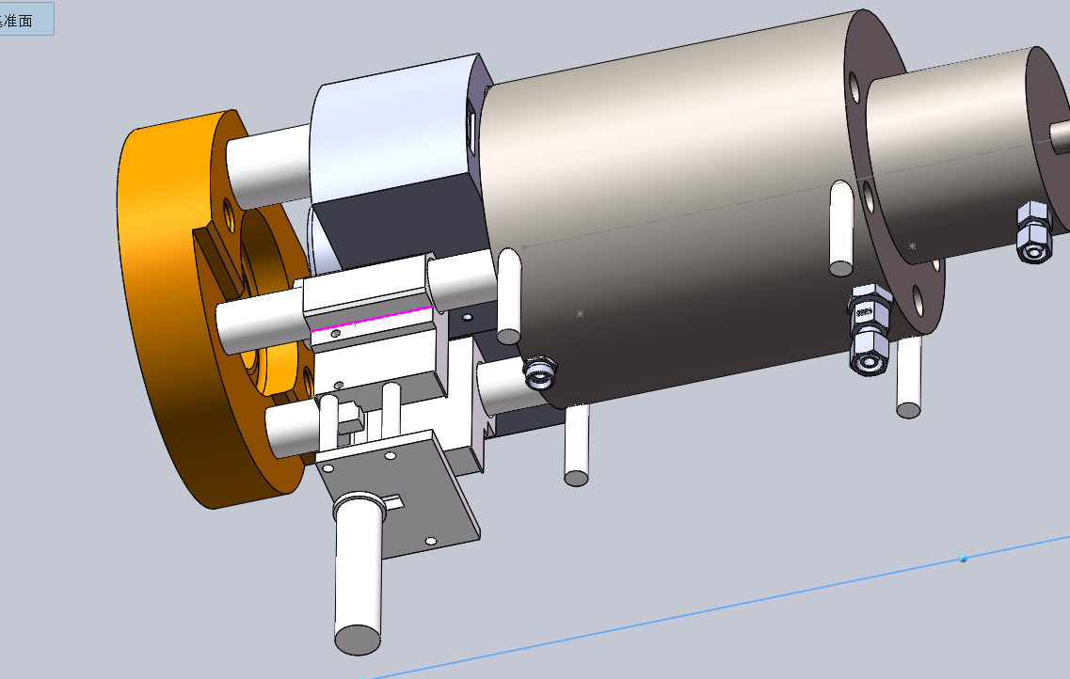
L1.7
L1.6
L1.5
Main Cylinder

●Operation Panel Instructions
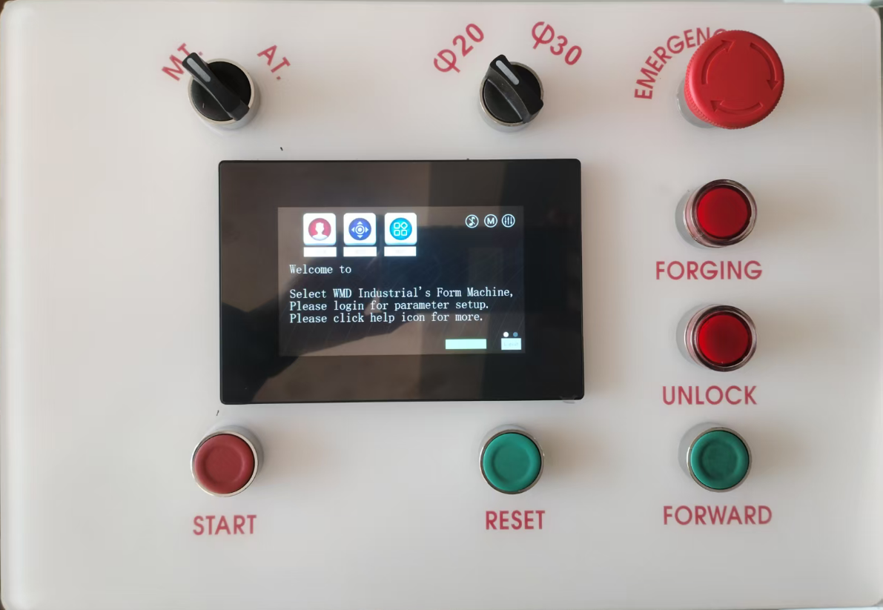
Manual/Automatic Mode Selection Switch
In manual mode, need to press the Forging button to process the forging action; After the proecssing is completed, remove the formed steel pipe and insert a new one. Press the forming button again to enter the next forming action of the system;
When selecting automatic mode, insert a new steel pipe in the preparation state, keep the steel pipe stationary for two seconds, and the system will directly enter the forming action without manually pressing the Forging button.

ø20 ø30 Pipe diameter selection switch
This switch is used to pre-set the system forming working pressure for the steel pipe to be formed. It has three levels, corresponding to 20Mpa (for steel pipe diameters less than or equal to 20mm, please select "1" level), 40Mpa (for steel pipe diameters greater than 20mm and less than or equal to 30mm, please select "2" level), and 60Mpa (for steel pipe diameters greater than 30mm, please select "3" level). When selecting a working pressure that is lower than the actual diameter of the steel pipe, it may cause the forming to not work properly, and the steel pipe end may not be fully formed or unable to form; When selecting a working pressure greater than the actual diameter of the steel pipe needed, the steel pipe end can be formed perfectly, but it will accelerate equipment fatigue。

Emergency stop button
When the emergency stop button is pressed, all actions stop and any buttons do not respond (unlocking the button once can undo the emergency stop action). In some cases, need to turned off the power, and after waiting for 10 seconds, then turn on the power to restore all button response functions; please note If the emergency stop is pressed during the forging processing, the forging processing will be terminated, and the tube splitting process don’t be restored even release the emergency stop button and restore program, so be care to press this Emergency stop button during the forging processing
Forging button
In manual mode, after inserting the steel pipe, press the button once to enter the forging action;
In automatic mode, insert the steel pipe and wait for 2 seconds. The system will directly enter the forging action.
Unlock button
When the emergency stop button is pressed, the system was locked, there is not respond when press any button. After clearing the fault, and release the Emergency button, pressing this Unlock button once and the system will be recoved
Stare Button + Reset Button
Pressing the Stare button and Reset button in same time, and release, the cylinder and the mold will go back to initial position, motor will stop, die and jig can be change

Stare Button +Forward Button
Pressing the Stare button and Forward button in same time and release, the cylinder and mold will go forward to preparing position, and waiting for insert tube for next action. in this position, motor will keep slow running and cooling oil.

●Preparation before work
This forming machine use 5 core cable for L1,L3,L5,N and GND, capacity are AC400,16A (The electrical control cabinet contains precision components and high-voltage power. Please not open this cabinet for Non skill person.)。
●Hydraulic oil
This equipment is an ultra-high pressure device with a rated working pressure of 63Mpa, using L-HM series anti-wear hydraulic oil. Suggest using hydraulic oil No. 46 for normal area, for cold area, need to change to N0.68 hydraulic oil, Regularly checking the cleanliness of hydraulic oil is very necessary. Ensuring the cleanliness of hydraulic oil is the most effective way to extend the service life of pressure systems。
***For WMD Form machine model 306, Before adding oil or changing oil, the exhaust air action of pump is needed. (Before adding oil, there is M5 bolt on the tank and by the side of the motor, remove this bolt, after completing adding oil, and wait for 8 to 10 minutes, then tighten up the bolt, it complete the exhaust air of pump.)

●Die and Jig
The die and jig used in this machine are high-precision components, and the inside of the mold should be kept cleaning. Before use, use an air gun to remove debris, and apply hydraulic oil to lubricate the mold cavity; The outer surface of the fixture needs to be lubricated with hydraulic oil, but make sure that the hydraulic oil does not touch the inside of the fixture to avoid affecting the clamping effect on the steel pipe.
●Tube
The steel tube to be formed should have a vertical cross-section and no burrs; before forming, the inner and outer sides of the tube are lubricated with hydraulic oil.
●Note for first Running
1．Take out the die and jig.
2．Turn on the power, switch the manual/automatic mode to manual mode, switch the pipe diameter selection switch to the left position (low pressure mode).
3．Press the start button and forward button in same time, check if the block 1 move forward to Preparation position, the block 1 near to stop block ( it is about 8mm), If there is an abnormality, in case press the emergency stop button, check if the motor is running, or is there hydraulic pressure of P1 detecting point.
4．Press the Stare button and Reset button once, check the Block 1 go back to ground position (near to the Main Cylinder), If there is an abnormality, in case press the emergency stop button, check if the motor is running, or is there hydraulic pressure of P2 detecting point.
5．Repeat steps 3 and 4 for 4-5 times.
6．Press the Stare button and Forward button, waiting the Block 1 go forward to preparation position.
7．Prepare a tube after burring, close to the senser L1.4, when the rear light turn on, press the Forging button, system run the forging procession.
8．Press the Stare button and Reset button.
9．Put Die and Jig into die slot.
10．Press the Stare button and the Forward button, the Block 1 move forward to preparation position.
11．Insert tube, the tube end need to touch the stop plate, than press the Forging button, system will auto complete forging processing, the block 1 will go back and jig will open when forging processing completed, then remove the tube.

●Operation Manual

1、Replace the die and Jig
Here are the replacement windows for die and jig
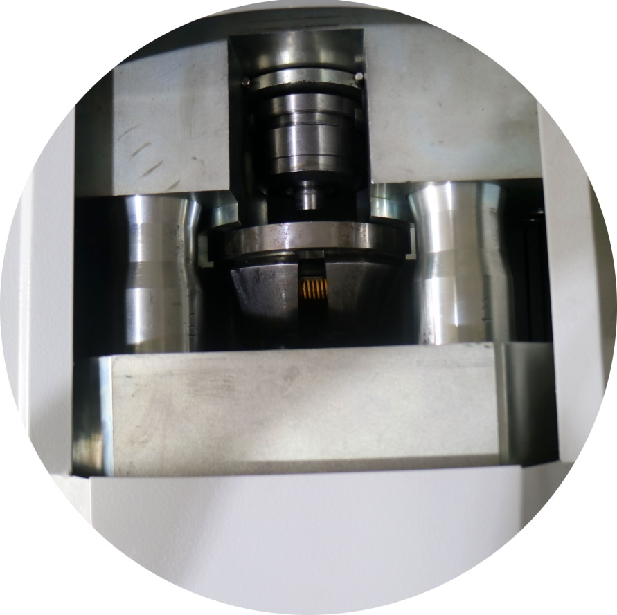
Press Start + Reset button, and the Block will go back to ground position.
- Take off Die and Jig。
- Put in Die and Jig。
2、Operating
In MT. Model (Manual Transmission)：
Press Start + Forward butto, and the Bloc1 will go forward to preparation position, lubricating oil on tube end。
- Put the tube into jig, and the tube end touch the Stop Plate, and hold on。
- Press Forging button, and it will process the forging 。
- When the process is completed, the Jig will release, and remove the tube in time。
- After remove tube, waiting the Block1 go forward to Preparation position, you can insert new tube for next working cycle.
In AT. Model (Auto Transmission)：
Press Start + Forward button, the Block1 will go forward to preparation position。
- lubricating oil on tube end。
- Put the tube into jig, and the tube end touch the Stop Plate, and hold on。

- Hold on and waiting 2 seconds,the forging process will run automatic.
- When the process is completed, the Jig will release, and remove the tube in time。
- After remove tube, waiting the Block1 go forward to Preparation position, you can insert new tube for next working cycle.

3、Emergency Stop
At any case, press the Emergency button, system will stop any procession, and system was hold until release Emergency button and press Unlock button, Emgergency button press down, system was locked, and there is not any action for any button.
4.Unlock
When Emergency button press down, system locked, it need release emergency button and then press Unlock button. Also in case, it can turn off the power, waiting for 10 seconds, and turn on again, the system will restart.
5、脱模失败处理，因钢管质量等原因，有可能发生钢管不能正常从模具中脱开，可通过以下操作，进行二次脱模作业：1、先按下按钮 急停按钮 2 次，系统会自动退回到开始位置（如果不能成功，可关电源，等待10秒，重新开关，按下按钮 启动+按钮 复位）；2、按下按钮 启动+按钮 解锁，系统会自动进行脱模作业；3、完成后，按下按钮 启动+按钮 复位，退回开始位置后，开始新的正常作业。（该二次脱模功能只有部分机型有该功能）

●Note of maintanence
1、Clean the dust from the photoelectric sensor: There is a photoelectric sensor near the steel pipe insertion port, primarily used to detect whether a steel pipe is inserted; regular cleaning of oil stains and dust is required.
2, Tighten up the center bolt of the Die slot,The Die slot bears a large tensile force when the mold is return, which has a significant impact on the central bolt and requires regular locking.
- Regularly lubricate the slide rail to maintain lubrication.
- Check regularly the oil level in the tank, keep oil level is between the red line on the tank
- Check regularly if the transmitter pointer of the filter is pointing to the yellow mark, if yes, need to change the filter core in time.

●Screen operation instructions
Note：
Screen operation has a direct impact on machine performance, and the system does not conduct safety checks, it may damage the machine. Please operate with caution!!

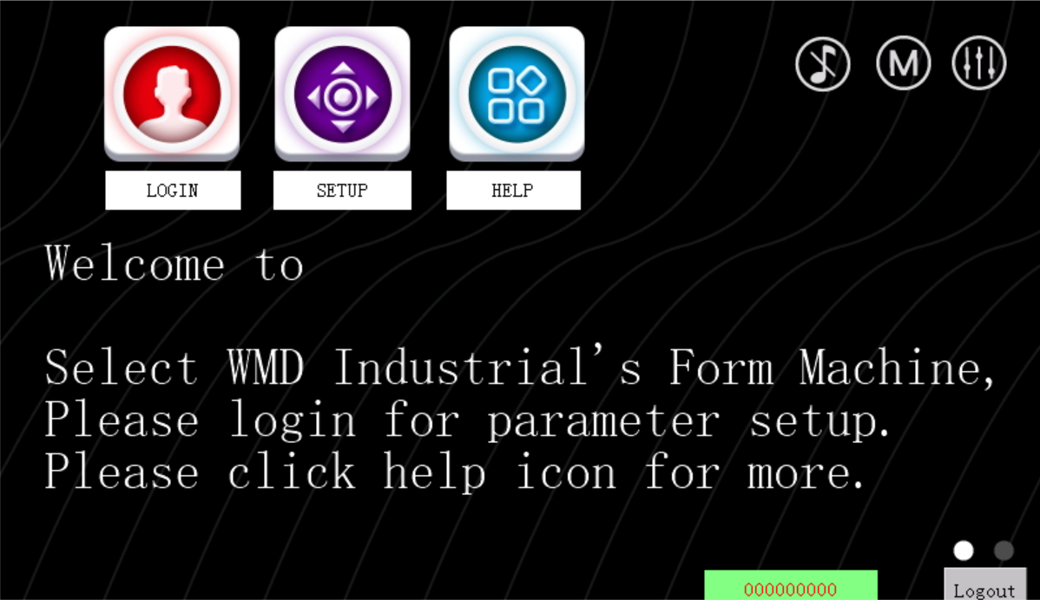
**Click the green numerical box to display the cumulative processing quantity
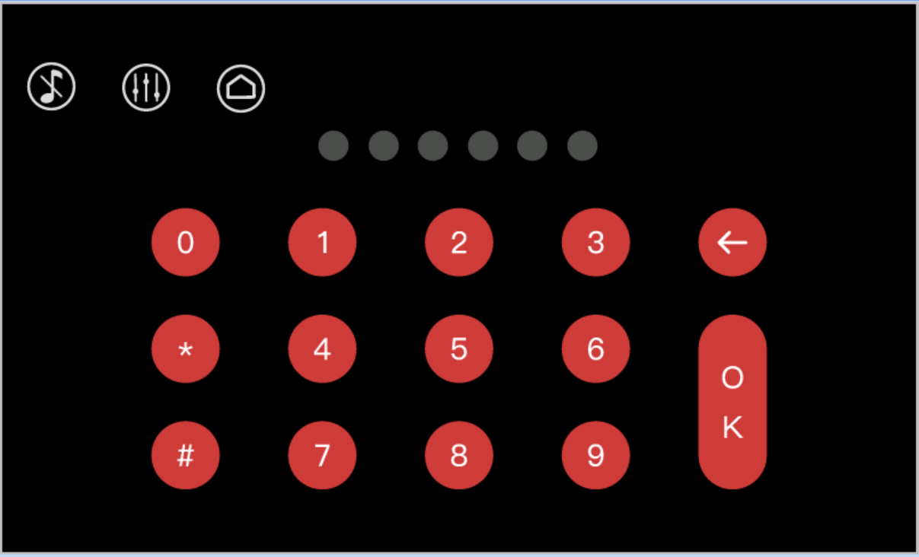
The above is the user login page，this device only has one user, and the password cannot be changed, to access the settings page, you need to log in.

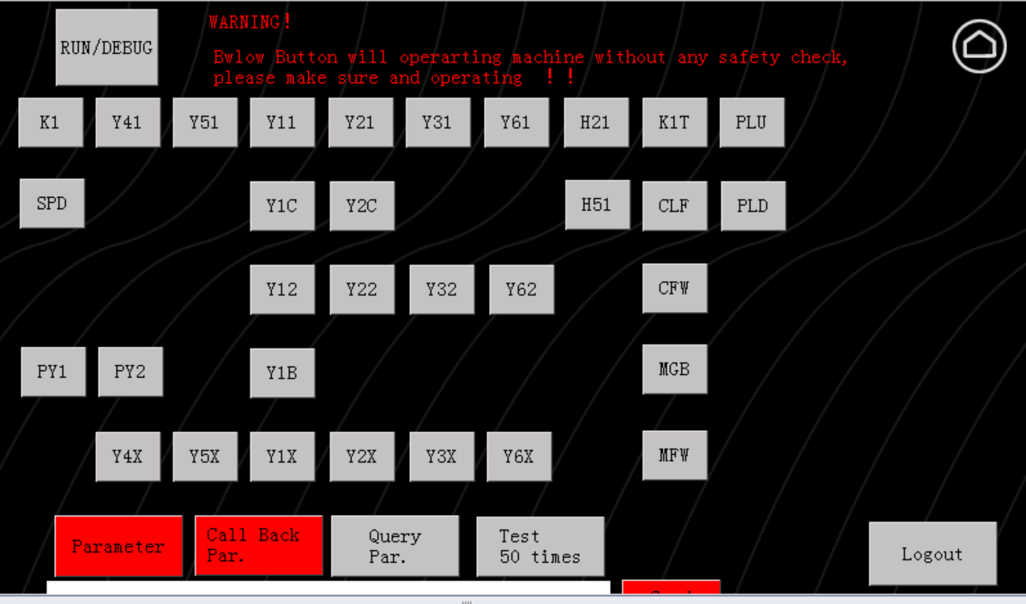
The above page is a setting page, primarily used for debugging various action functions:
- Run/Debug：Grey indicates the operation mode, while green (pressed) indicates the debugging mode; in operation mode, the panel buttons are enable, while the buttons on the upper screen are disable; in debugging mode, the panel buttons are disable (except for the emergency stop button), while the buttons on the screen are enable;
- K1/SPD: For models 306 and 60, the SPD is effective, the gray motor stops, and the green (pressed) motor works; for model 308, K1 is effective, the gray motor stops, and the green (pressed) motor works;
- Y41：Low pressure hydraulic way valve，gray is off(non hydraulic pressure),green is on (hydraulic pressure up)；
- Y4X：offset Y41；
- Y51：high pressure hydraulic way valve，gray is off(non hydraulic pressure),green is on (hydraulic pressure up)；
- Y5X：offset Y51；
- Y11：Clamping cylinder return valve，gray is off(clamping cylinder extend), green is on ；only effective on model 308
- Y1C：Clamping cylinder pre-relief valve,gray is off(hold pressure of clamping cylinder), green is on(release pressure of clamping cylinder) ；
- Y12: Clamping cylinder valve，gray is off, green is on ( clamping cylinder indent)；
- Y1B: Clamping cylinder booster valve，gray is off ( booster stop), green is on (booster working)；
- Y1X：offset Y11,Y12,Y1B；
- Y21：Forging cylinder return valve，gray is off, green is on ( forging cylinder indent)；only effective on model 308
- Y2C：Forging cylinder pre-relief valve, gray is off(hold pressure of forging cylinder), green is on ( release pressure of forging cylinder) ；
- Y22: Forging cylinder valve，gray is off, green is on ( forging cylinder extend)；；
- Y2X：offset Y21,Y22,Y2C；
- Y31：Forging cylinder return valve ( low hydraulic pressure way )，gray is off, green is on ( forging cylinder indent)；
- Y32: Forging cylinder forging valve ( low hydraulic pressure way )，gray is off, green is on ( forging cylinder extend );
- Y3X：offset Y31, Y32；
- Y61：Stop plate down valve, gray is off, green is on ( stop plate go down);
- Y62：Stop plate up valve, gray is off, green is on ( stop plate go up);
- Y6X：offset Y61, Y62；
- H21：LED light switch；
- H51：LED light switch；
- K1T：motor jogging；only effective on model 308
- CLF: Block 1 moves forward (booster working); prerequisite: motor must be in working state.
- CFW: Block 1 moves forward rapidly(booster not working); prerequisite: motor must be in working state.
- MGB: Forging cylinder backward; prerequisite: motor must be in working state.
- MFW: Forging cylinder forward; prerequisite: motor must be in working state.
- PLU: Stop plate up; prerequisite: motor must be in working state.
- PLD: Stop plate down; prerequisite: motor must be in working state.
**The above "forward/backward" refers to facing the screen; the moving to close to operator is forward, the moving leave to operator is backward.
- Parameter：This button enters the system parameter settings page；
- Call back Par.：This button enters the page to restore default system parameters；
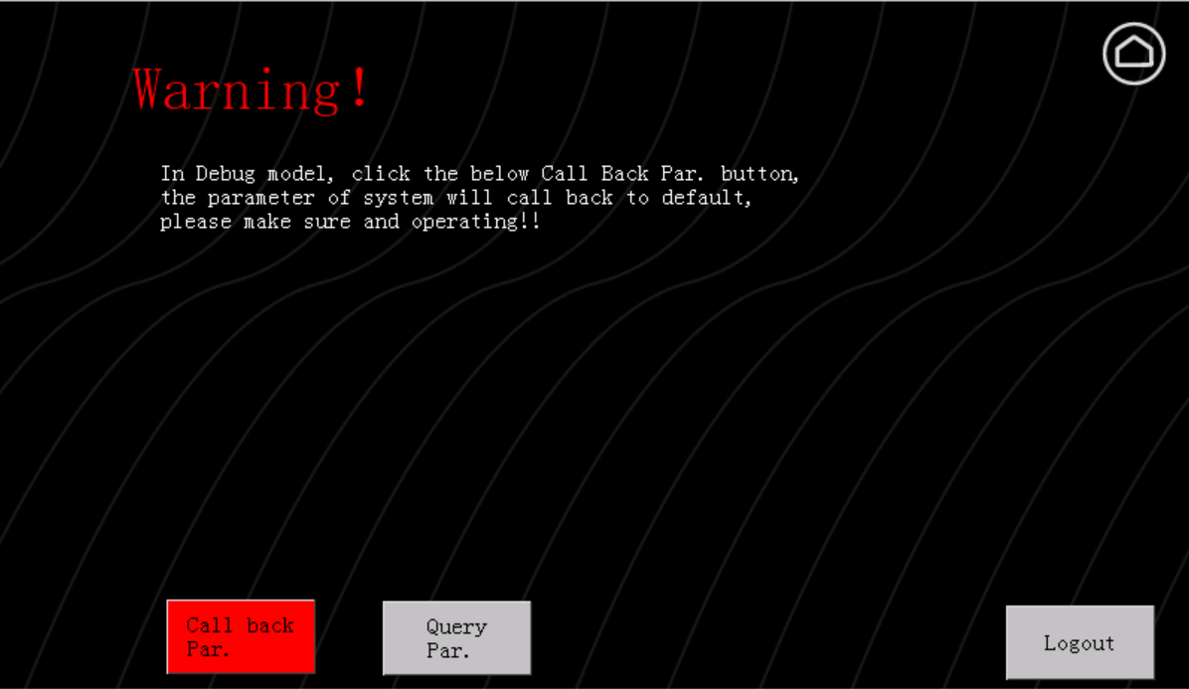
- Query Par.：This button enters the page to query system parameters；
- Logout：Logs out, and the system enters normal operation mode；

Parameters Setting
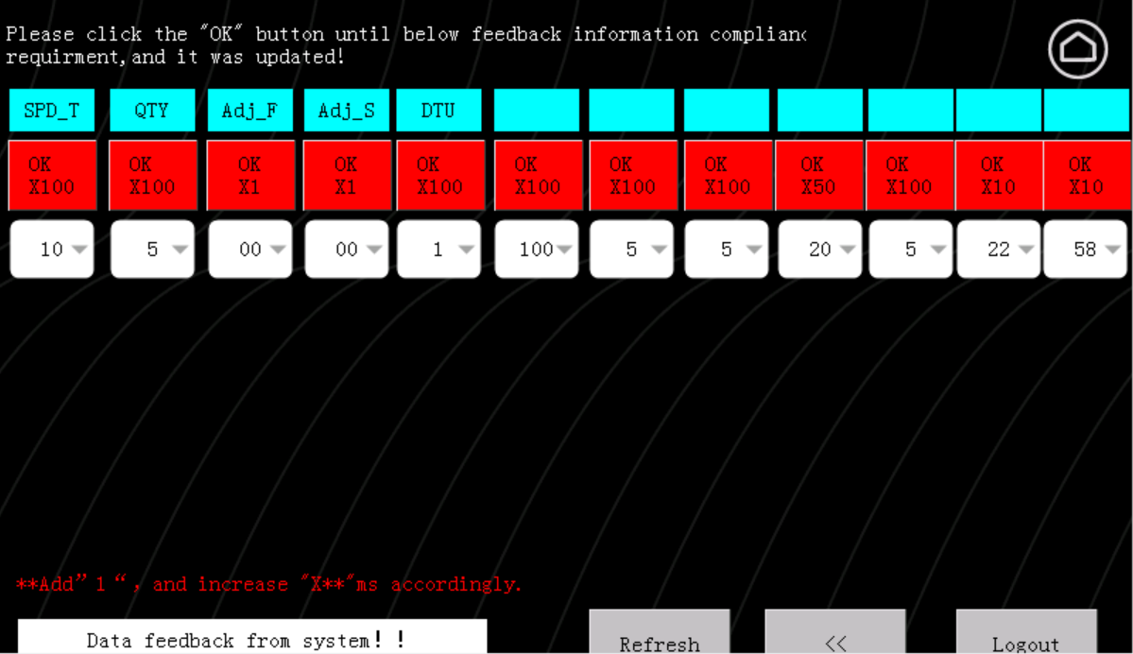
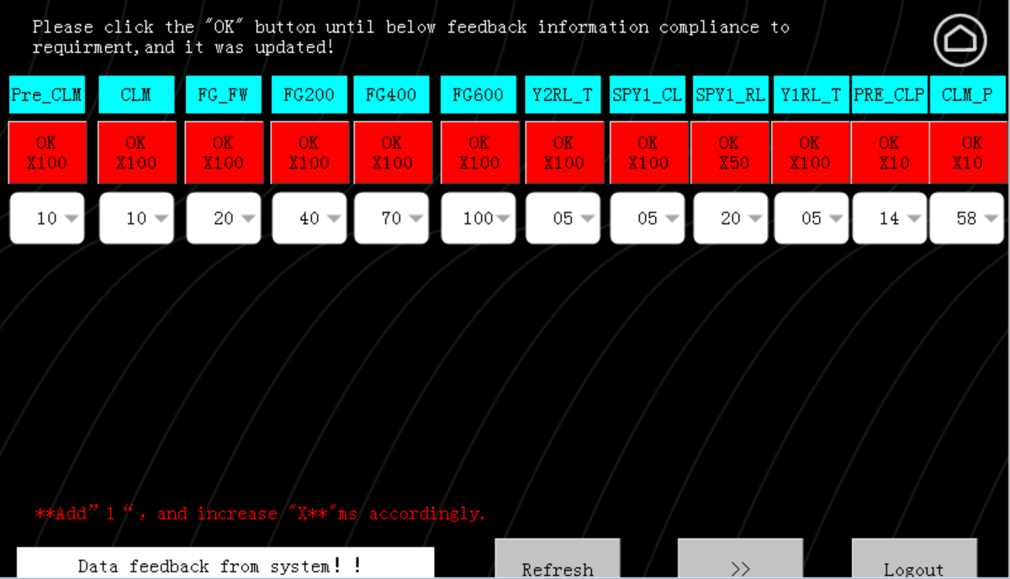
The above pages are the system parameter setting pages. All parameters on these pages correspond to time delays/waiting times for corresponding work processes during system working, each parameter has a significant impact on system operation.

- Pre_CLM: This is the action delay time for clamping the steel pipe before the stop plate descends. If pre-clamping is insufficient, increase the value. If the stop plate has difficulty descending, decrease the value.
- CLM: This corresponds to the action delay time for deep clamping of the steel pipe. If the steel pipe moves during forging, increase the value.
- FG_FW: This corresponds to the action delay time of the forging cylinder's fast move forward.
- FG200: This corresponds to the forging action delay time of the first pressure level (small diameter steel pipes , < 20mm). If the corresponding steel pipe is not fully forged, increase the value.
- FG400: This corresponds to the forming action delay time of the second pressure level (medium diameter steel pipes, >20mm and <30mm). If the corresponding steel pipe is not fully forged, increase the value.
- FG600: This corresponds to the forming action delay time for the third pressure level (large diameter steel pipes, >30mm). If the corresponding steel pipe is not fully forged, increase the value.
- Y2RL_T: This corresponds to the pre-pressure relief delay for the forging cylinder after forging is completed.
- SPY1_CL: This corresponds to the delay for clamping the steel pipe after forging is completed, used to increase clamping pressure.
- SPY1_RL: This corresponds to the delay for releasing the steel pipe after pipe-mold separation, each increment of 1 adds 50ms.
- Y1RL_T: This corresponds to the pre-pressure relief delay for the clamping cylinder.
- PRE_CLP: Pre-clamp pressure setting, can be used to set the pressure for pre-clamping the pipe before the stop plate descends. If the pipe is not clamped after the stop plate descends, increase the value. If the stop plate cannot descend, decrease the value.
- CLM_P: Forging clamp pressure setting.
- SPD_T: Duration for releasing clamping force after forging is completed, during pipe-mold separation. If the pipe and mold cannot separate, increase the value.

- Refresh：Reads the current values of the corresponding system parameters；
- Logout：Logs out; enters normal operation mode；

**After adjusting any parameters, click the Confirm button and observe the feedback information in the feedback window below until the feedback information matches the set value, indicating the system has confirmed the modification. Otherwise, repeat confirmation. For example: For Pre_CLM, if the set value is 8, the feedback information should be "PA1 feedback as:800", where 800 represents 800 ms.

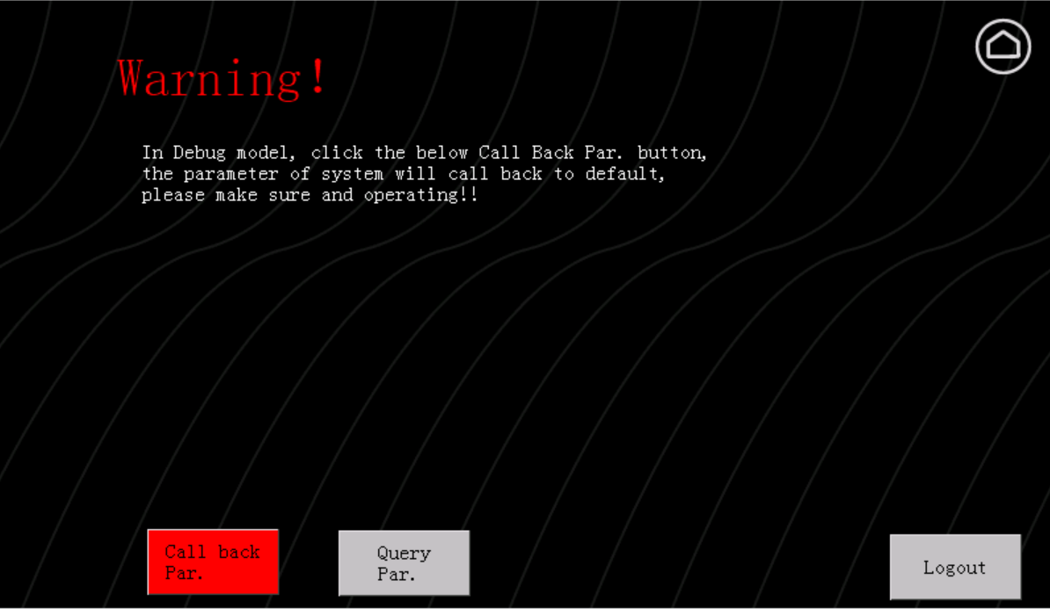
**Call back Par. the "Run/Debug" button on the previous debugging page must be in the green (pressed) state for the action to take effect. After the action is completed, feedback is as follows:
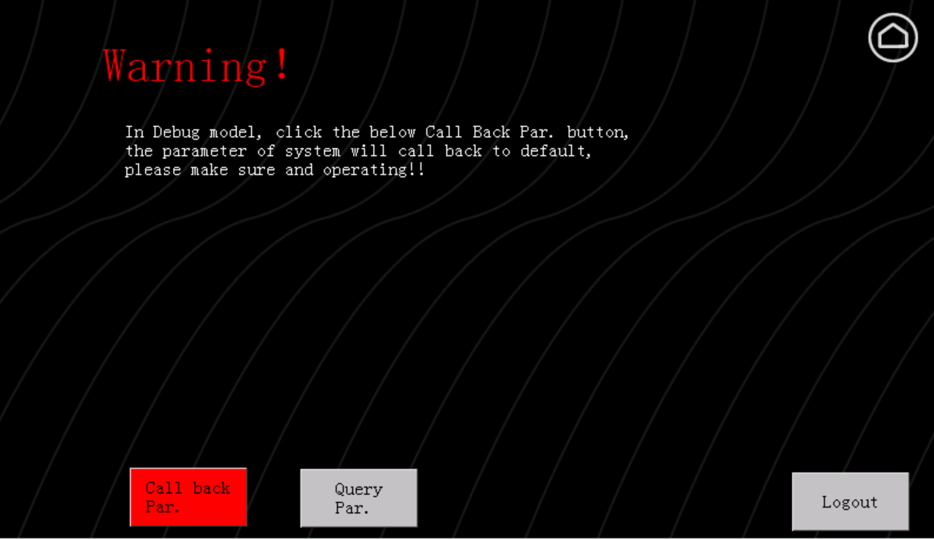
**Query Par. the "Run/Debug" button on the previous debugging page must be in the green (pressed) state for the action to take effect. After the action is completed, feedback displays the query results.；

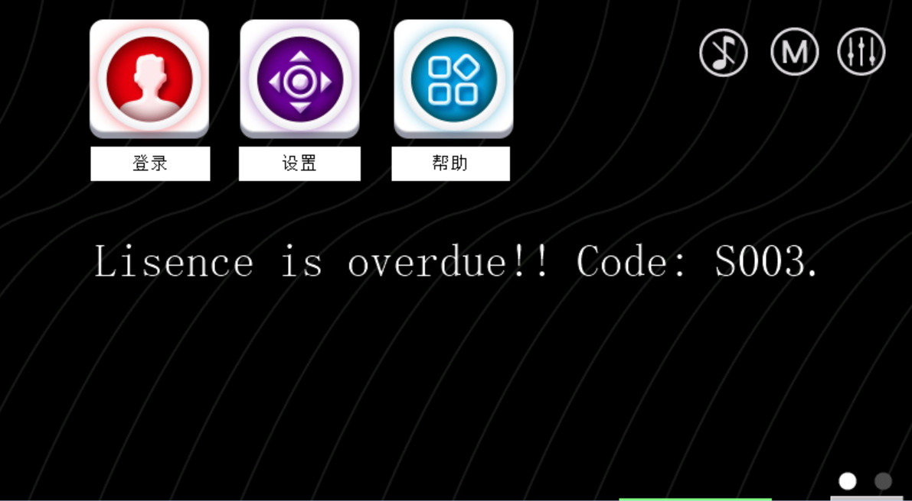
The above shows the system lock screen when the system time limit expires; activation is required for normal use；
Click the Help button to enter the help page；
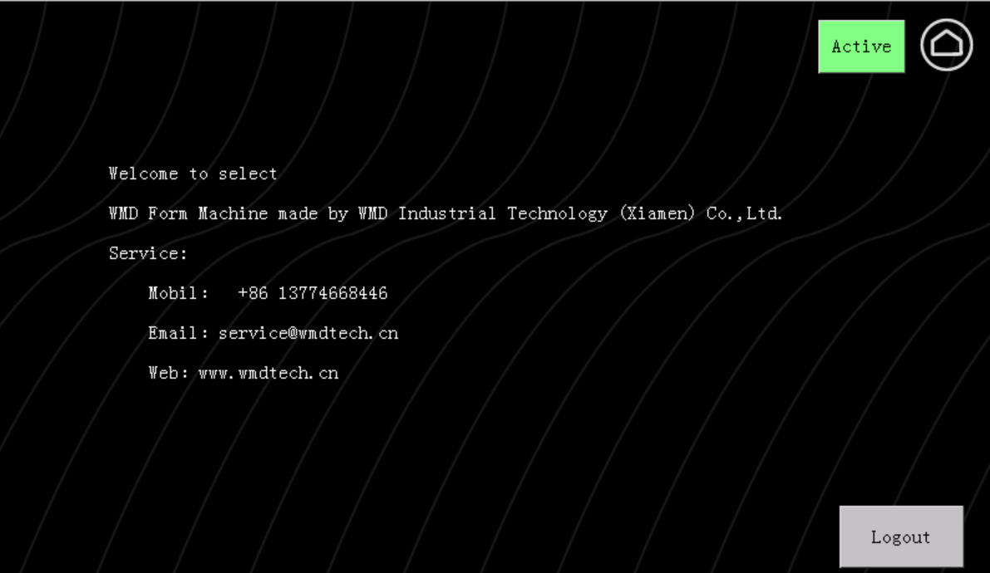
Click the button Activate; enter the password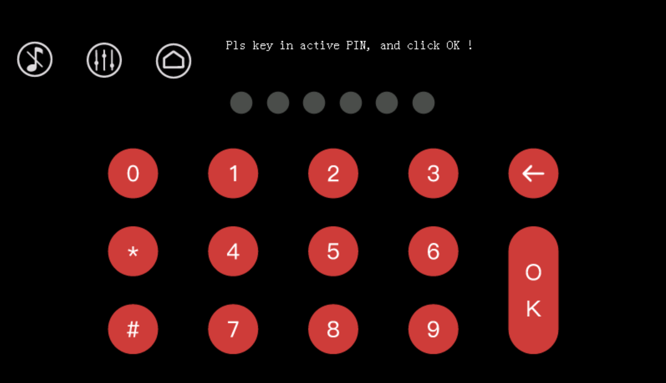

Feedback message: "lisence release as:1;" indicates successful unlocking.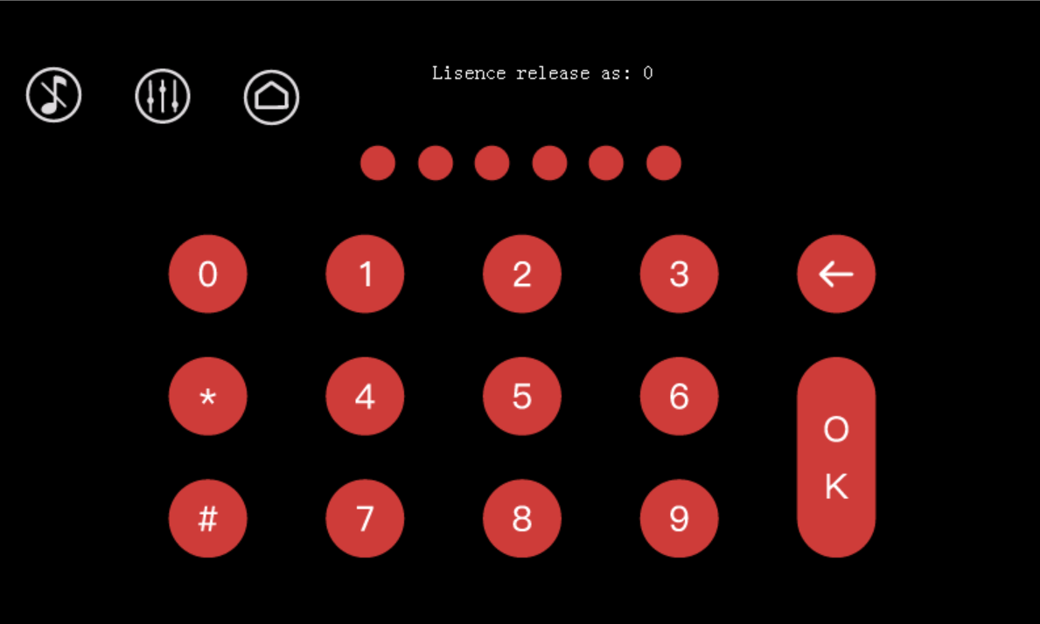
- Error Code Handling
Error Code is the prompt code displayed when an error occurs during system operation. The following are the main error codes and corresponding handling methods.

- PM01, System initial parameters lost.
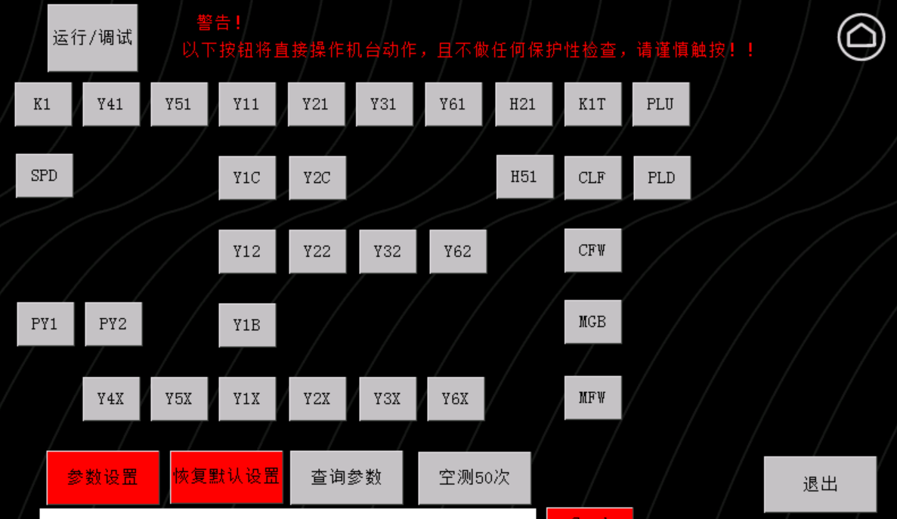
1
2
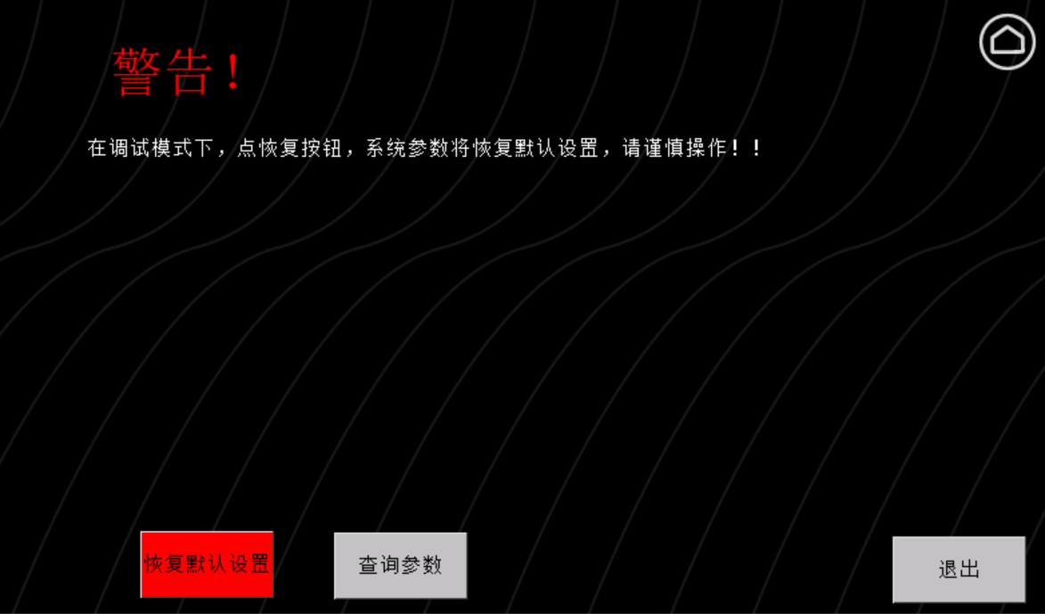
4
3
- A007/A013, Stop plate did not lower into position.
a.Check if the low-pressure oil circuit pressure (P1 measuring point) is normal (approximately 6MPa).
B.Manual debugging: Check the stop plate action and corresponding sensor signals for normalcy (when the stop plate is in the up position, the L1.6 sensor light is off, and the L1.7 sensor light is on).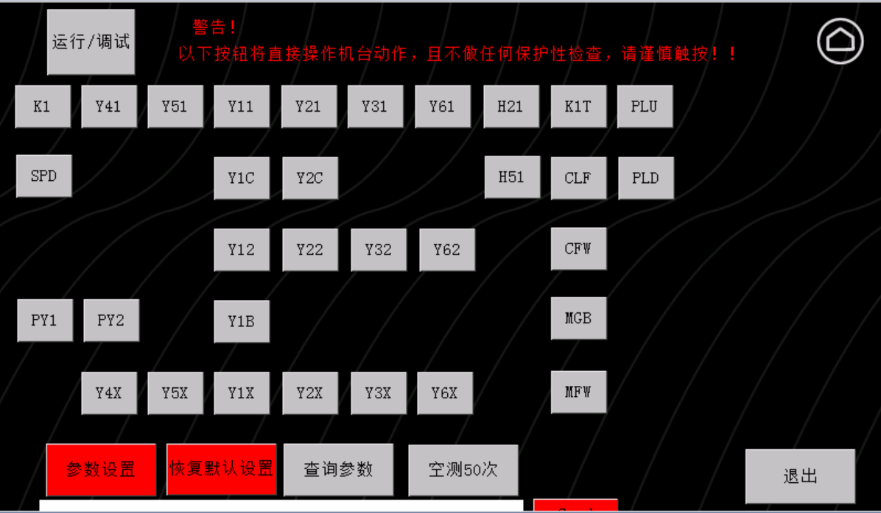
4
3
2
1
When the stop plate is lowered, the L1.6 sensor light is on, and the L1.7 sensor light is off.
2
3
4
1
c. Check if initial parameters are lost.
2
1
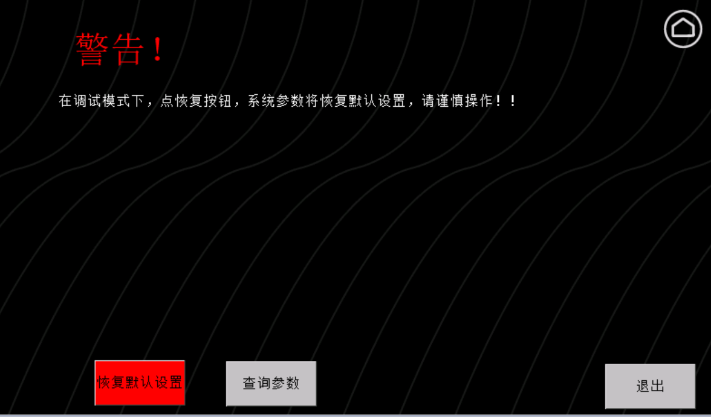
3
Check if the feedback value is normal. If values like -6800... appear, it indicates parameter loss. Restoration method refers to PM01.

d. L1.5 sensor error.
- PD01/PU01

WMD Form Sensor system
Main Cylinder
Clamp Cylinder
L1.5
L1.6
L1.7

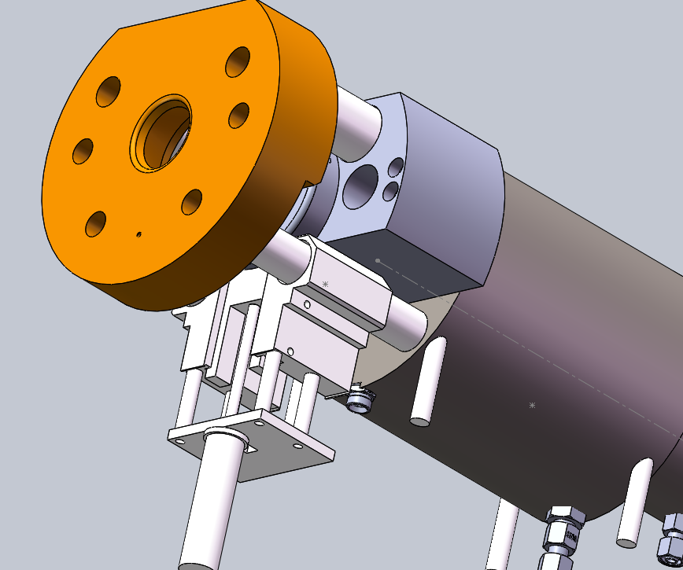
Block 1
Cylinder 3
Stop Plate
Block 3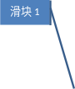
Block 2
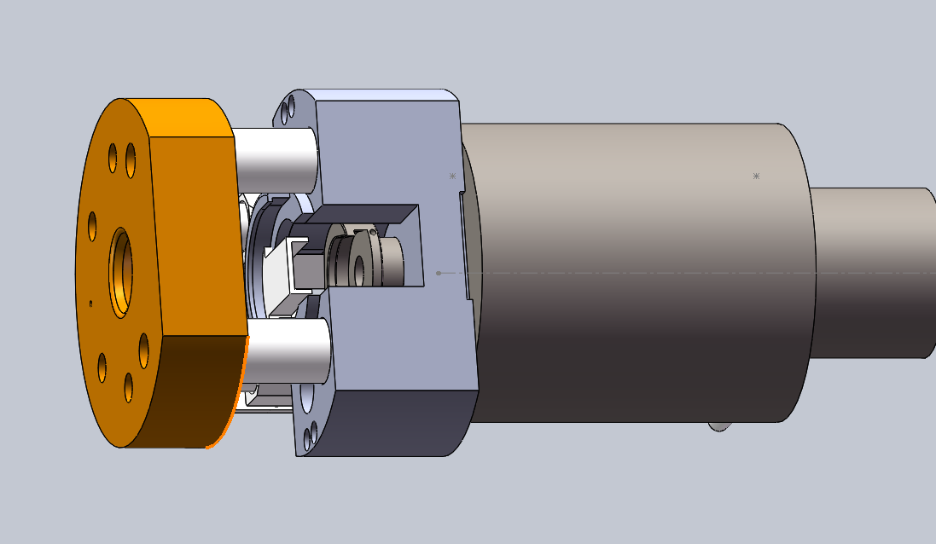
Die Slot
Stop Block
Block1
Stop Plate
Stop Plate
Die Slot
Block1
Stop Block
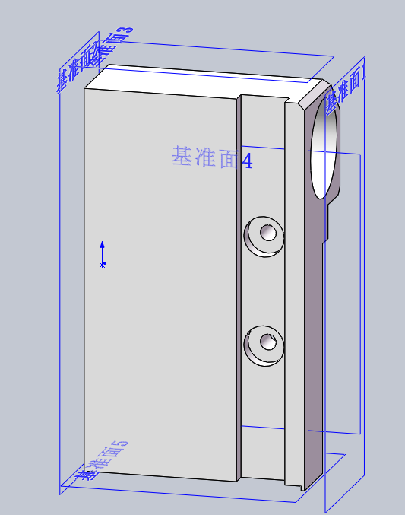
Slot
·There are mainly three sensors: L1.5, L1.6, L1.7
- L1.5 is used to determine the status of the main cylinder. When the die holder separates from Slide Block 1, the L1.5 light is off. When the die holder is in contact with Slide Block 1, the L1.5 light is on.
- L1.6 and L1.7 are used to determine whether the stop plate is in the raised or lowered state. When the stop plate is raised, the L1.7 light is on, and the L1.6 light is off. When the stop plate is lowered, the L1.7 light is off, and the L1.6 light is on.

·Replacing the Sensor
- First, remove the small cylinder.
- Remove the old sensor.
- Screw the sensor end until it is flush with the groove bottom surface of Slide slot, and fix it with screws.
- Reinstall the small cylinder.

